**Federal Deposit Insurance Corporation (FDIC**)

**Purpose of the Federal Deposit Insurance Corporation (FDIC**)

The FDIC aims to maintain stability and public confidence in the U.S. financial system through key functions:

**Insuring Deposits**: The FDIC insures deposits up to $250,000 per depositor, per insured bank, per account category. This insurance prevents bank runs by guaranteeing deposit safety, ensuring depositor confidence.

**Supervising Financial Institution**s: The FDIC supervises and examines banks to ensure safe operations and compliance with laws, helping prevent bank failures and promoting sound practices.

**Managing Receiverships:** In case of a bank failure, the FDIC acts as receiver, taking over assets, paying insured depositors, and liquidating assets to repay creditors, minimizing costs to the Deposit Insurance Fund.

**Promoting Consumer Confidenc**e: By safeguarding deposits and ensuring institutional health, the FDIC maintains consumer trust, crucial for financial system stability.

**Educating Consumers and Bankers:** The FDIC educates consumers on safe banking and deposit insurance and provides resources and training to bankers for effective management and regulatory compliance.

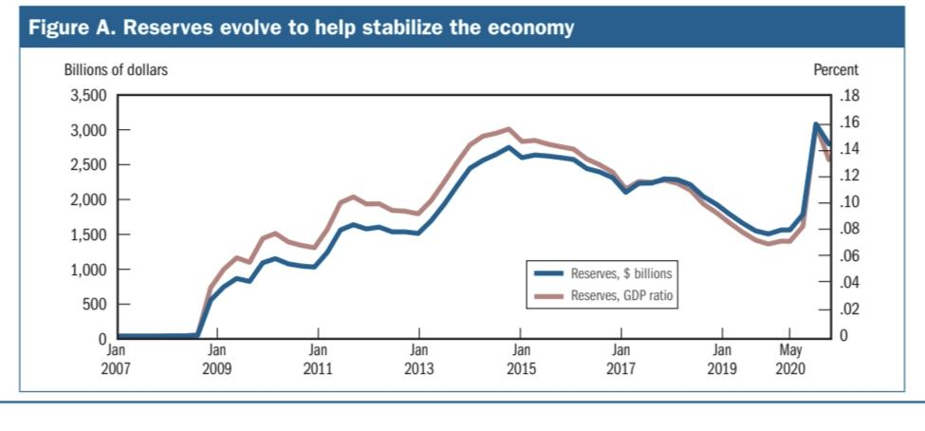

**Key Concepts in U.S. Banking Systems**

1. **CIF (Customer Information File):**

A database banks use to store and manage customer data, including personal details, account information, and transaction history.

Example: A bank’s CIF for John Doe includes his personal info, accounts, loans, and transaction records, facilitating personalized service and regulatory compliance.

1. **AIF (Alternative Investment Fund**

Pooled investment vehicles that invest in non-traditional assets such as hedge funds, private equity, and real estate.

Example: A private equity fund investing in start-ups, offering high returns with higher risks, used by investors to diversify beyond stocks and bonds.

1. **Concentration:**

The degree to which a bank’s exposure is focused on a specific borrower, sector, or area, affecting risk.

Example: A bank heavily invested in the real estate sector faces higher risk if the market crashes, prompting diversification into other sectors.

1. **Margin:**

Lending Margin: The difference between the interest rate on loans and the rate on deposits.

Trading Margin: Collateral required by brokers for trading.

Example: A bank charges 5% on loans, pays 2% on deposits (3% margin), and requires a 50% margin from investors in trading.

1. **Market Price:**

The current price at which an asset can be bought or sold, determined by market supply and demand.

Example: The market price of Apple shares at $150, monitored by banks to manage investment portfolios and risk.

**Bank concentrating for United States**

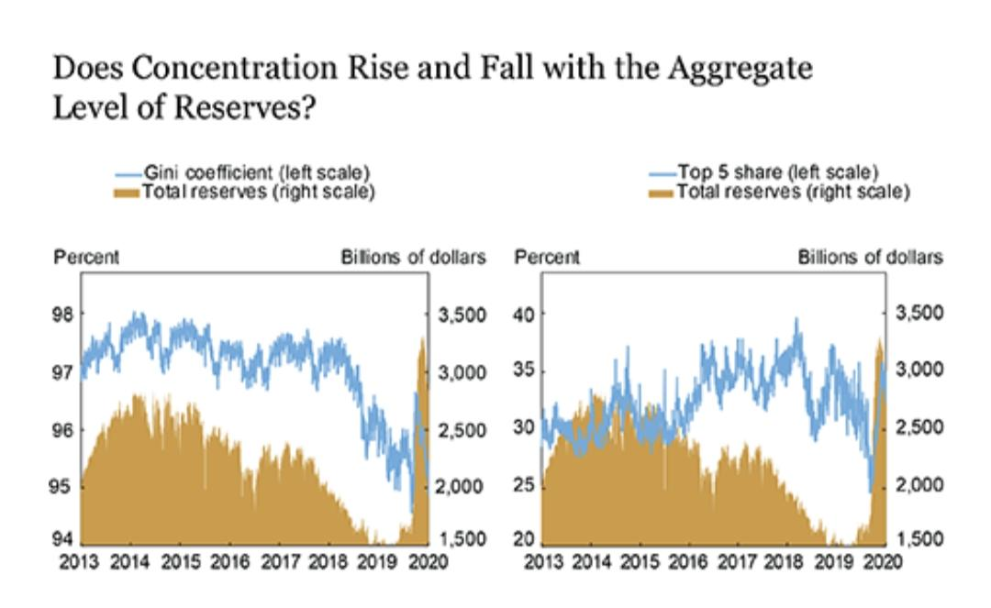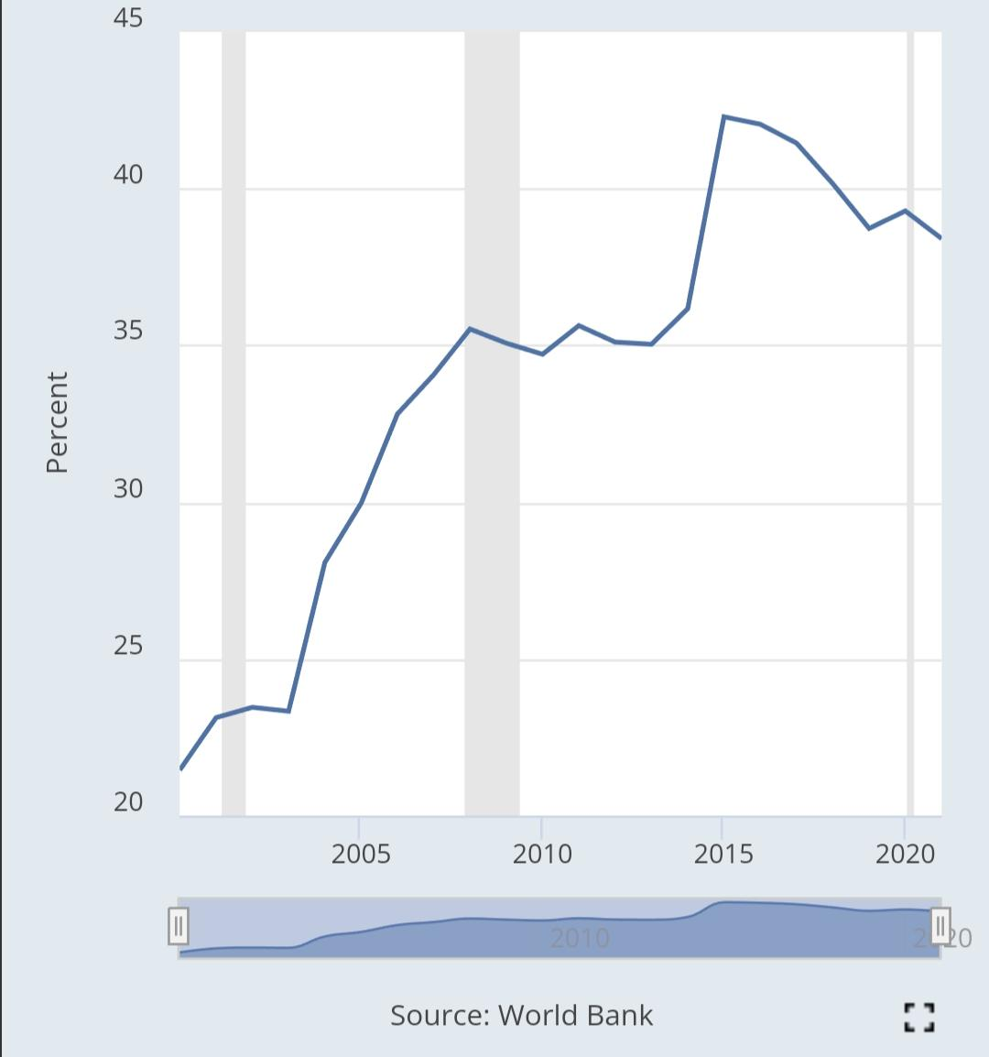

**Office of the Comptroller of the Currency (OCC)**

The OCC, part of the U.S. Department of the Treasury, regulates and supervises national banks, federal savings associations, and branches of foreign banks. It ensures these institutions operate safely, provide fair access to services, and comply with laws.

**Key Functions**:

**Chartering Banks**: Grants charters, approves mergers and acquisitions.

**Supervision and Regulation**: Conducts regular examinations for safety, soundness, and legal compliance.

**Enforcement Actions**: Issues orders, fines, and removes officers for violations.

**Rulemaking**: Sets rules on capital requirements, lending practices, and consumer protection.

**Consumer Protection**: Enforces fair lending and financial privacy laws.

**Promoting Innovation**: Guides on new technologies and products.

**Risk Management**: Monitors and addresses banking system risks.

**Community Reinvestment**: Ensures compliance with the Community Reinvestment Act.

**Statistics:**

Banks Supervised: 1,055

Value of Bank Assets: $15.6 trillion (66% of U.S. commercial banking assets)

OCC Examiners: 2,349 across 70 locations

FY 2024 Budget: $1.289 billion

**Independence and Accountability**:

**Independence**: Operates within the Treasury framework.

**Accountability**: Subject to Treasury and Congressional oversight.

**OCC supervised institutions in United States**

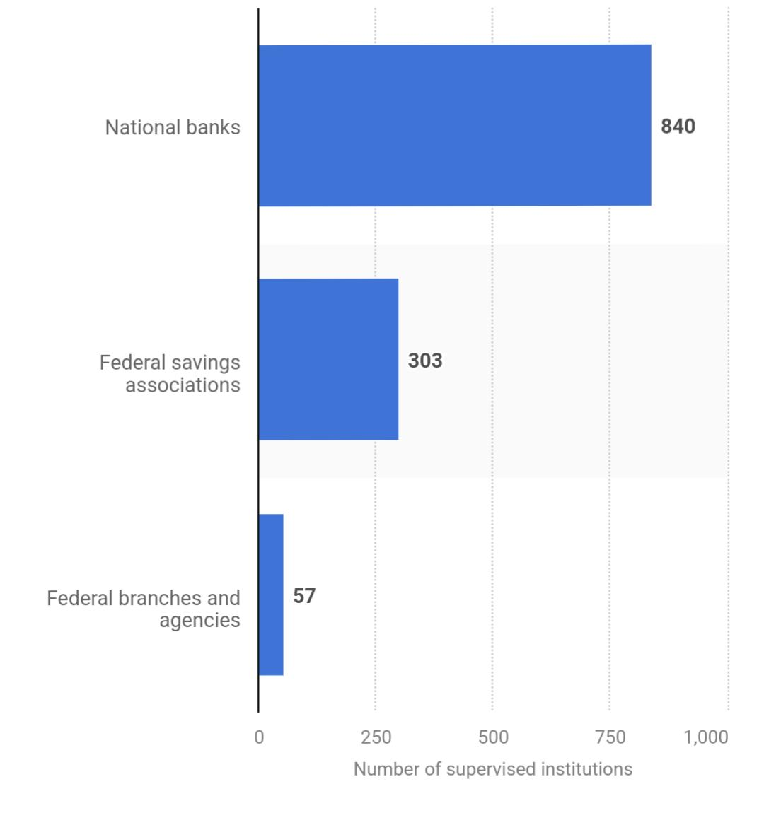

**Federal Reserve System of the U.S.**

**Structure:**

**Board of Governors:**

* Seven members appointed by the President, confirmed by the Senate, serving 14-year terms.
* Oversees Federal Reserve Banks and implements monetary policy.

**Federal Reserve Banks:**

* 12 regional banks serving specific U.S. districts.
* Each has a president appointed by its board of directors.

**Federal Open Market Committee (FOMC):**

* Composed of the seven Board of Governors members and five of the 12 Federal Reserve Bank presidents.
* Oversees open market operations.

**Functions:**

**Monetary Policy:**

* Controls money supply and credit to promote stable prices, maximum employment, and moderate interest rates.
* Utilizes tools like open market operations, the discount rate, and reserve requirements.

**Regulation and Supervision:**

* Supervises and regulates financial institutions to ensure safety, soundness, and legal compliance.

**Financial Stability:**

* Monitors and addresses financial system risks, acts as a lender of last resort during distress.

**Payment Systems:**

* Facilitates electronic payments, check clearing, and other financial transactions for efficient fund transfers.

**Consumer Protection:**

* Enforces consumer protection laws, ensuring fair treatment in financial dealings (e.g., credit cards, mortgages).

**Economic Research and Data:**

* Conducts economic research, collects, and publishes economic data to inform policy decisions**.**

**Independence and Accountability:**

* Independence: Operates independently from government to protect monetary policy from political pressures.
* 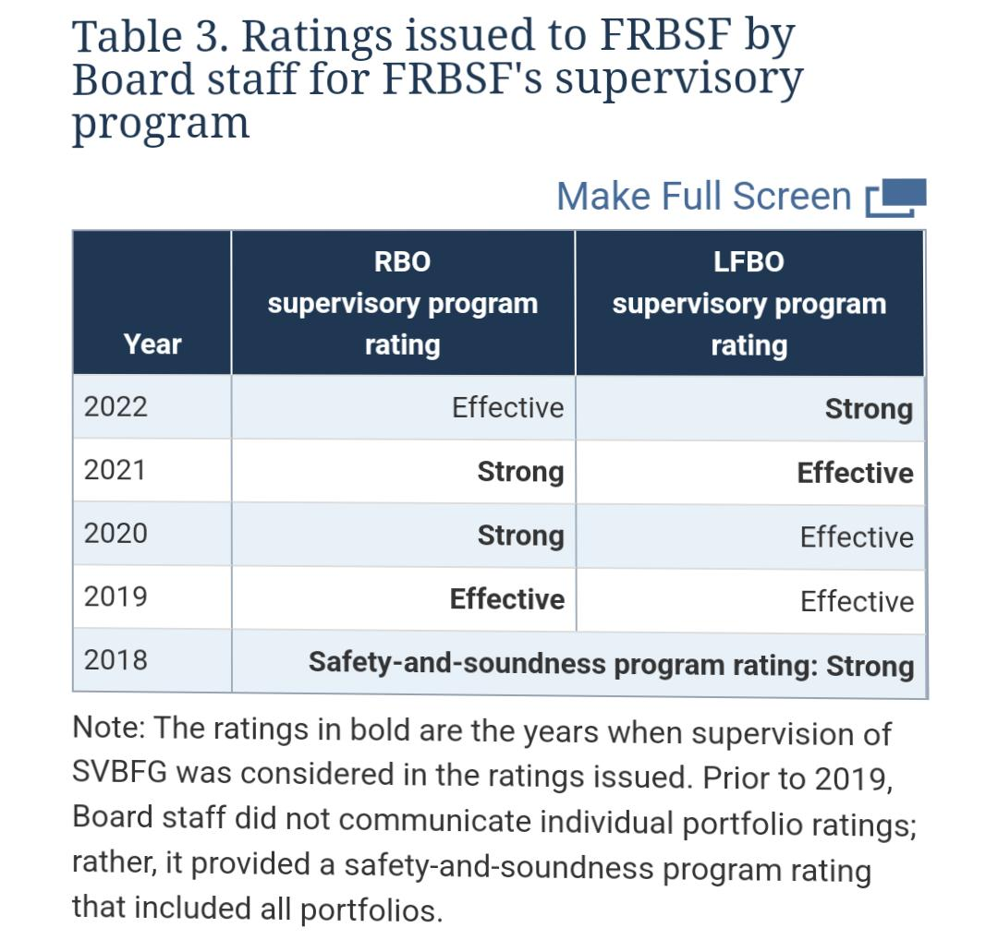Accountability: Subject to Congressional oversight; the Chairman regularly testifies before Congress.

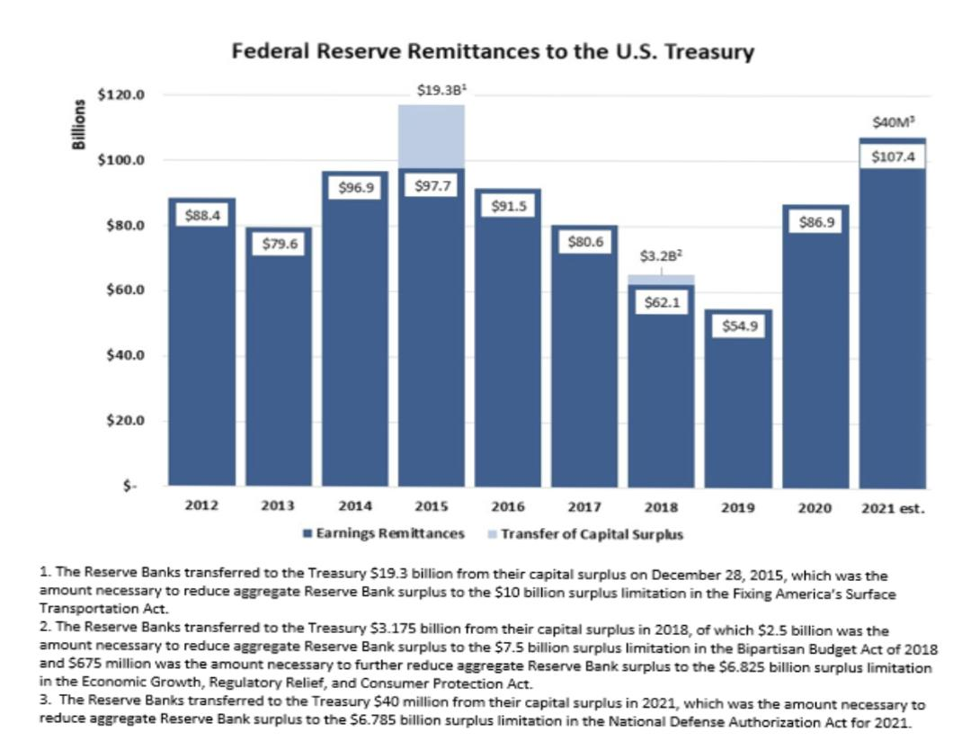**Performance of Federal reserve system of US**